Requirements/Design Specification

**Assign Quote Function Does Not allow Claiming**

**GH 463 – CR 13937**

Revision History

|  |  |  |  |
| --- | --- | --- | --- |
| **Date** | **Revision** | **Description** | **Author** |
| 6/1/2015 | 1.0 | Initial Version with Requirements | Roger Behm |
|  |  |  |  |
|  |  |  |  |
|  |  |  |  |
|  |  |  |  |

The information furnished herein by Republic Services Inc. is proprietary and confidential to Republic Services Inc. personnel and is not to be duplicated, published, or disclosed to any third party in whole or in part without permission from Republic Services, Inc.

© Copyright 2012, Republic Services Inc. - All rights reserved.

Table of contents

1 Business Requirements/Owner – Brittany Smith 6

2 Assumptions 6

3 Design 6

4 InfoPro/TIBCO/BI Impacts 8

5 Report Changes 8

6 Appendix 8

# Business Requirements/Owner – Brittany Smith

For an Existing Customer on the Customer Site Info page, the Assign Quote function does not allow "Claiming" user to continue with the quote. To reproduce, create a change of owner quote, assign the quote on the Customer Site Info page, then claim ownership and try to navigate to the Config page

# Assumptions

Only for new temporary industrial containers.

# Design

Existing Customer - Working  
[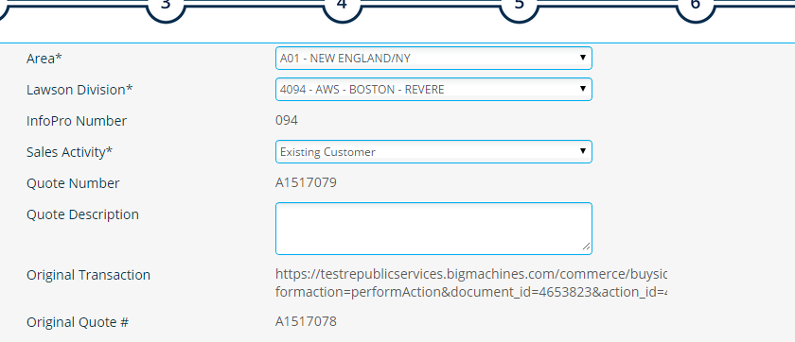](https://cloud.githubusercontent.com/assets/9666166/7888340/a3c4c38c-05ec-11e5-9b99-ed1cf9549cdb.png)

[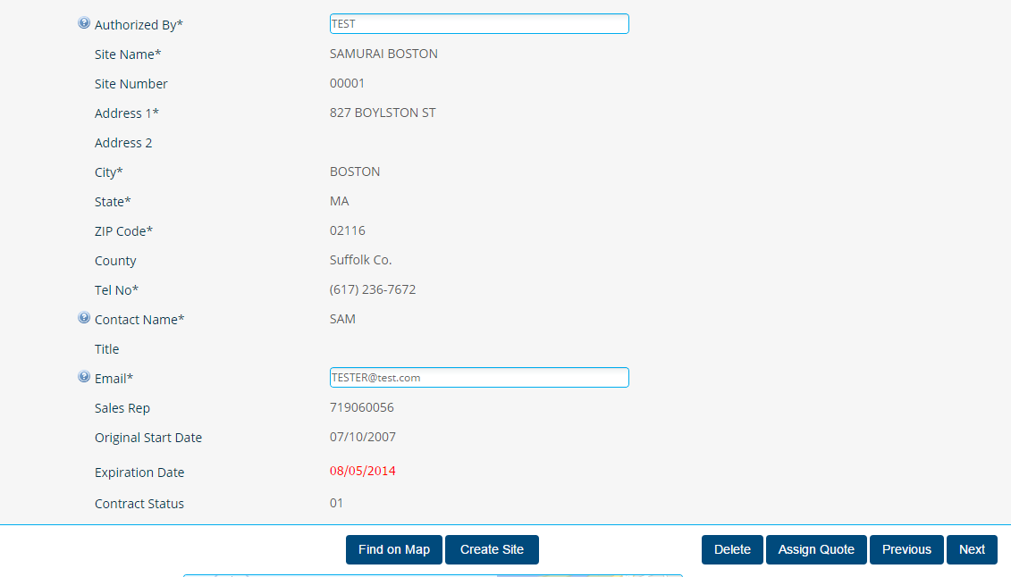](https://cloud.githubusercontent.com/assets/9666166/7888352/c7e0cebe-05ec-11e5-9327-fac4e15f33ba.png)

Change of Owner – Notice in red box we are missing some buttons  
[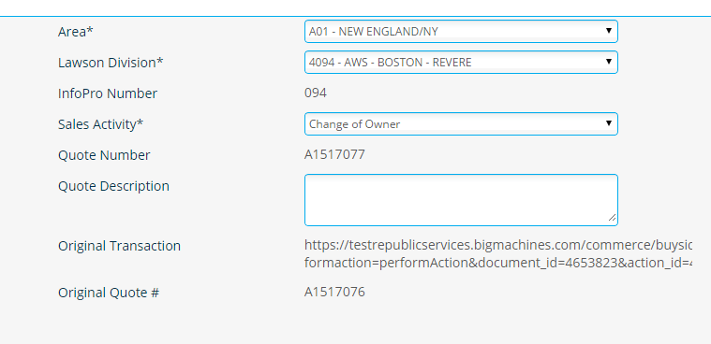](https://cloud.githubusercontent.com/assets/9666166/7888301/58f67332-05ec-11e5-92d5-67b4a9d1c880.png)

[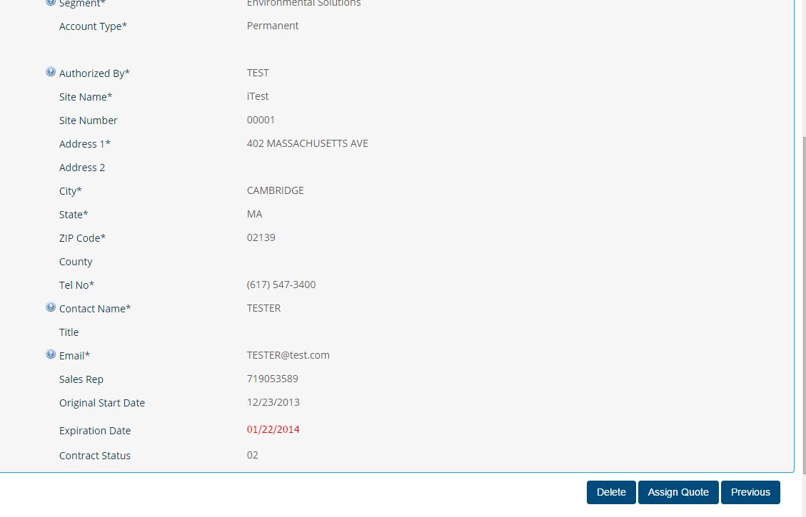](https://cloud.githubusercontent.com/assets/9666166/7888307/6dbb4c2a-05ec-11e5-913c-71adc35011dc.png)

For change of owner sales activity, allow users to assign, claim, and complete quotes. Change of owner needs access to the quote in order to complete it. User access rights is the most probable culprit. Grant claiming users rights to access and complete the quote.

This is only occurring for 'Sales Agent' profiles. If you are logged in as a Full Access user, you will not encounter this error.

If assigning a change of owner quote, add a transition rule to the correct step. When Claim ownership is clicked, transition to 'Start'. Upon that next action, transition to 'Existing Customer: View Account/Site'. Steps to fix include:

* add new transition rule on the next action (on the start page)
* run an advanced condition to check if change of owner quote is claimed
* if true is returned: transition to 'Existing Customer: View Account/Site'

# InfoPro/TIBCO/BI Impacts

No new variables. This is permission issue.

# Report Changes

Should have no reporting affects

# Appendix